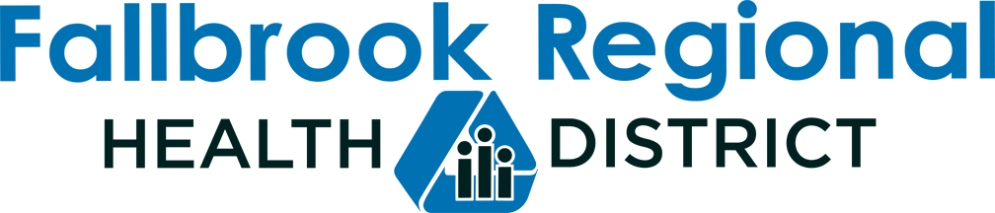

AGENDA

STRATEGIC PLANNING COMMITTEE

Wednesday, August 18, 2021 at 5:00 P.M.

In accordance with the current State of Emergency and the Governor’s Executive Order N-25-20, of March 12, 2020 and N-33-20 of March 19, 2020, teleconferencing will be used for this meeting. Board members, staff and members of the public will be able to participate by webinar by using the following link: https://us02web.zoom.us/j/89674799373
Meeting ID: 896 7479 9373. Participants will need to download the Zoom app on their mobile device. Members of the public will also be able to participate by telephone using the following dial in information: Dial in #: (310) 372-7549, Passcode 660448.

Committee Members: Jennifer Jeffries, Chair and Howard Salmon, Co-chair
Staff: CEO Rachel Mason and Executive Assistant Linda Bannerman

Call to Order/Roll Call
- Public Comments
- Discussion Items
  - District and CHWC Measurables and Success Indicators
  - Financial Reserves – Economic Uncertainties
  - CHC – Grant Application and Scoring
  - CHC – Grant Funding Levels
  - Staffing – Administrative Officer
- Board Member Comments and Future Agenda Items
- Adjournment
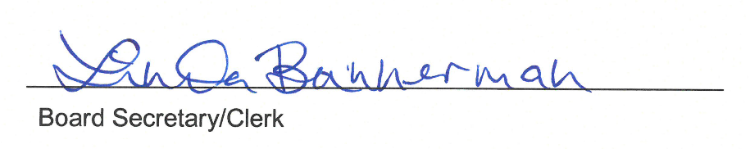

I certify that on August 17, 2021, I posted a copy of the foregoing agenda near the regular meeting place of the Board of Directors of Fallbrook Regional Health District, said time being at least 24 hours in advance of the meeting. The American with Disabilities Act provides that no qualified individual with a disability shall be excluded from participation in or denied the benefits of District business. If you need assistance to participate in this meeting, please contact the District office 24 hours prior to the meeting at 760-731-9187.

